ITA0435 – STATISTICS WITH R PROGRAMMING FOR VISUALIZATION
NAME : R.SABARISH
REG NO ; 192324092
UNIT V PLOTTING AND REGRESSION ANALYSIS IN R
1.SALES TREND AND REVENUE FORECASTING
# =====================================================
# SALES TREND AND REVENUE FORECASTING (BASE R VERSION)
# =====================================================

set.seed(123)

# Monthly Data for 5 Years (60 Months)
months <- 1:60
sales <- 50000 + 2000 * months + rnorm(60, 0, 10000)

data <- data.frame(Month = months, Sales = sales)

# Category-wise Sales
categories <- c("Electronics", "Clothing", "Groceries", "Furniture")
category_sales <- c(1200000, 800000, 600000, 400000)

# -----------------------------------------------------
# 1. Line Chart
# -----------------------------------------------------

plot(data$Month, data$Sales, type="l",
main="Monthly Sales Trend",
xlab="Month",
ylab="Sales Revenue",
col="blue",
lwd=2)

# -----------------------------------------------------
# Bar Plot (Category-wise)
# -----------------------------------------------------

barplot(category_sales,
names.arg=categories,
main="Category-wise Sales",
col="lightgreen")

# -----------------------------------------------------
# 2. Pie Chart
# -----------------------------------------------------

pie(category_sales,
labels=categories,
main="Sales Distribution by Category",
col=rainbow(4))

# -----------------------------------------------------
# 3. Low-Level Custom Plot
# -----------------------------------------------------

plot(data$Month, data$Sales, type="n",
main="Customized Sales Plot",
xlab="Month",
ylab="Sales")

lines(data$Month, data$Sales, col="red", lwd=2)
axis(1, at=seq(0,60,by=6))
axis(2)
box()

# -----------------------------------------------------
# 4. Linear Regression
# -----------------------------------------------------

model <- lm(Sales ~ Month, data=data)
summary_model <- summary(model)

print(summary_model)

# Add Regression Line
abline(model, col="darkgreen", lwd=2)

# -----------------------------------------------------
# 5. Interpretation
# -----------------------------------------------------

cat("\nIntercept:", coef(model)[1], "\n")
cat("Slope:", coef(model)[2], "\n")
cat("R-squared:", summary_model$r.squared, "\n")

# -----------------------------------------------------
# 6. Save Graphs
# -----------------------------------------------------

png("Line_Chart.png")
plot(data$Month, data$Sales, type="l", col="blue")
dev.off()

png("Bar_Plot.png")
barplot(category_sales, names.arg=categories)
dev.off()

png("Pie_Chart.png")
pie(category_sales, labels=categories)
dev.off()

cat("\nGraphs Saved Successfully!\n")

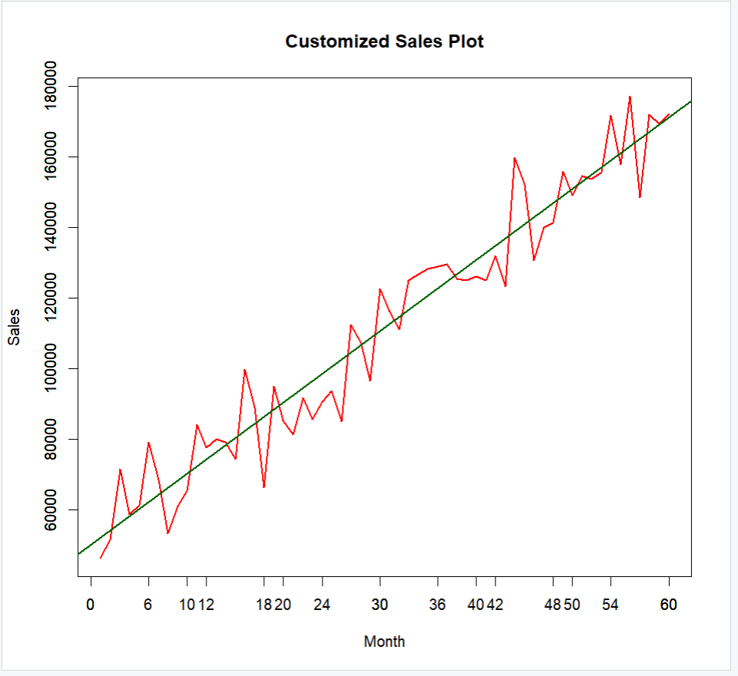
2. HEALTHCARE DATA AND DISEASE RISK ANALYSIS
# =====================================================
# HEALTHCARE DATA AND DISEASE RISK ANALYSIS
# =====================================================

set.seed(123)

# Generate Sample Data (200 Patients)
n <- 200

age <- sample(20:70, n, replace = TRUE)
BMI <- round(rnorm(n, 25, 4), 1)
blood_pressure <- round(90 + 0.5*age + 0.8*BMI + rnorm(n, 0, 5), 1)

# Disease Probability (Logistic Model Simulation)
prob_disease <- 1 / (1 + exp(-(-8 + 0.05*age + 0.1*BMI)))
disease <- ifelse(runif(n) < prob_disease, "Yes", "No")

health_data <- data.frame(age, BMI, blood_pressure, disease)

# -----------------------------------------------------
# 1. Histogram and Boxplot (BMI)
# -----------------------------------------------------

hist(health_data$BMI,
main="BMI Distribution",
xlab="BMI",
col="lightblue")

boxplot(health_data$BMI,
main="Boxplot of BMI",
col="orange")

# -----------------------------------------------------
# 2. Scatter Plot (Age vs Blood Pressure)
# -----------------------------------------------------

plot(health_data$age, health_data$blood_pressure,
main="Age vs Blood Pressure",
xlab="Age",
ylab="Blood Pressure",
col="blue",
pch=19)

# -----------------------------------------------------
# 3. Multiple Linear Regression
# Predict Blood Pressure using Age & BMI
# -----------------------------------------------------

linear_model <- lm(blood_pressure ~ age + BMI, data=health_data)
summary(linear_model)

# -----------------------------------------------------
# 4. Logistic Regression
# Predict Disease (Yes/No)
# -----------------------------------------------------

health_data$disease_binary <- ifelse(health_data$disease=="Yes",1,0)

logistic_model <- glm(disease_binary ~ age + BMI,
data=health_data,
family=binomial)

summary(logistic_model)

# -----------------------------------------------------
# 5. Odds Ratios
# -----------------------------------------------------

odds_ratios <- exp(coef(logistic_model))
print("Odds Ratios:")
print(odds_ratios)

# -----------------------------------------------------
# 6. Advanced Visualization using ggplot2
# -----------------------------------------------------

install.packages("ggplot2") # Run once if not installed
library(ggplot2)

ggplot(health_data, aes(x=BMI, fill=disease)) +
geom_histogram(alpha=0.6, position="identity", bins=20) +
labs(title="BMI Distribution by Disease Status")

ggplot(health_data, aes(x=age, y=blood_pressure, color=disease)) +
geom_point() +
geom_smooth(method="lm", se=FALSE) +
labs(title="Age vs Blood Pressure by Disease")

# -----------------------------------------------------
# 7. Save Graphs
# -----------------------------------------------------

png("BMI_Histogram.png")
hist(health_data$BMI, col="lightblue")
dev.off()

png("Age_BP_Scatter.png")
plot(health_data$age, health_data$blood_pressure)
dev.off()

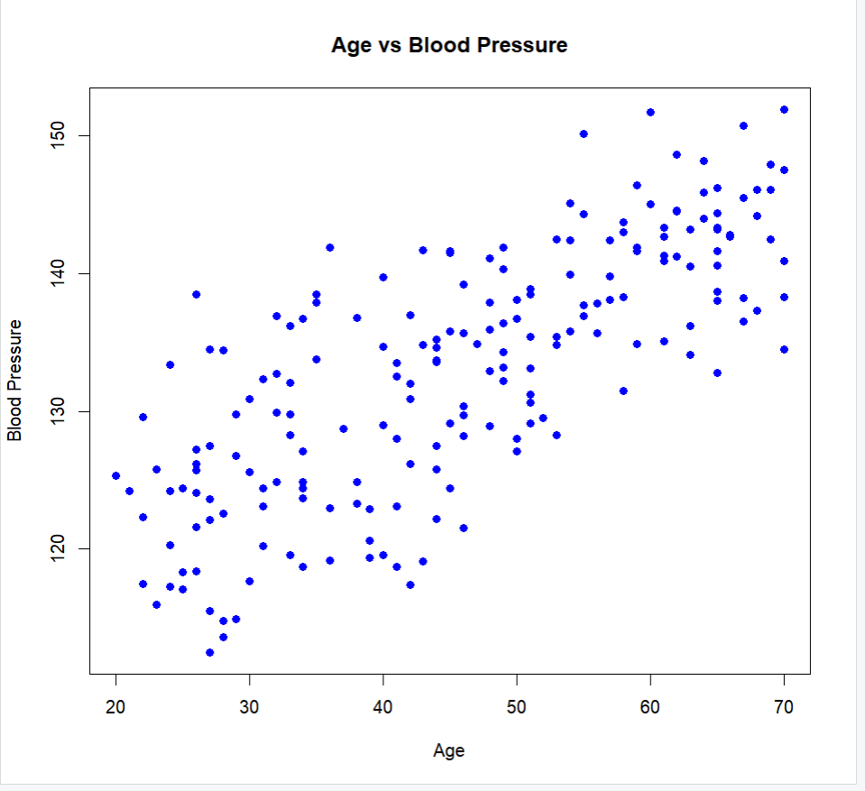
cat("Graphs Saved Successfully!")

3. EMPLOYEE PRODUCTIVITY ANALYSIS
# =====================================================
# EMPLOYEE PRODUCTIVITY ANALYSIS
# =====================================================

set.seed(123)

# Generate Sample Data (250 Employees)
n <- 250

experience <- round(runif(n, 1, 20),1)
training_hours <- round(runif(n, 10, 100),1)
working_hours <- round(runif(n, 6, 10),1)

# Productivity Score (Simulated)
productivity <- round(50 + 2*experience + 0.5*training_hours +
rnorm(n,0,10),1)

department <- sample(c("HR","IT","Sales","Finance"),
n, replace=TRUE)

emp_data <- data.frame(experience, training_hours,
working_hours, productivity, department)

# -----------------------------------------------------
# 1. Histogram & Boxplot (Productivity)
# -----------------------------------------------------

hist(emp_data$productivity,
main="Productivity Distribution",
xlab="Productivity Score",
col="lightblue",
border="black")

boxplot(emp_data$productivity,
main="Boxplot of Productivity",
col="orange",
horizontal=TRUE)

# -----------------------------------------------------
# 2. Scatter Plot (Experience vs Productivity)
# -----------------------------------------------------

plot(emp_data$experience, emp_data$productivity,
main="Experience vs Productivity",
xlab="Experience (Years)",
ylab="Productivity Score",
col="blue",
pch=19)

# Add regression line (low-level function)
abline(lm(productivity ~ experience, data=emp_data),
col="red", lwd=2)

# -----------------------------------------------------
# 3. Multiple Linear Regression
# Predict Productivity using Experience & Training
# -----------------------------------------------------

model <- lm(productivity ~ experience + training_hours,
data=emp_data)

summary_model <- summary(model)
print(summary_model)

# -----------------------------------------------------
# 4. Interpretation (Printed)
# -----------------------------------------------------

cat("\nIntercept:", coef(model)[1])
cat("\nExperience Coefficient:", coef(model)[2])
cat("\nTraining Coefficient:", coef(model)[3])
cat("\nR-squared:", summary_model$r.squared, "\n")

# -----------------------------------------------------
# 5. Lattice Graphics (Department-wise Comparison)
# -----------------------------------------------------

install.packages("lattice") # Run once
library(lattice)

bwplot(productivity ~ department,
data=emp_data,
col="green",
main="Department-wise Productivity Comparison")

# -----------------------------------------------------
# 6. Low-Level Customization Example
# -----------------------------------------------------

plot(emp_data$training_hours, emp_data$productivity,
type="n",
main="Customized Training vs Productivity",
xlab="Training Hours",
ylab="Productivity")

points(emp_data$training_hours, emp_data$productivity,
col="purple", pch=16)

axis(1, at=seq(0,100,20))
axis(2)
box()

# -----------------------------------------------------
# 7. Save Plots in PDF
# -----------------------------------------------------

pdf("Employee_Productivity_Plots.pdf")

hist(emp_data$productivity, col="lightblue",
main="Productivity Distribution")

boxplot(emp_data$productivity, col="orange",
main="Productivity Boxplot")

plot(emp_data$experience, emp_data$productivity,
col="blue", pch=19,
main="Experience vs Productivity")
abline(lm(productivity ~ experience, data=emp_data),
col="red")

bwplot(productivity ~ department, data=emp_data)

dev.off()

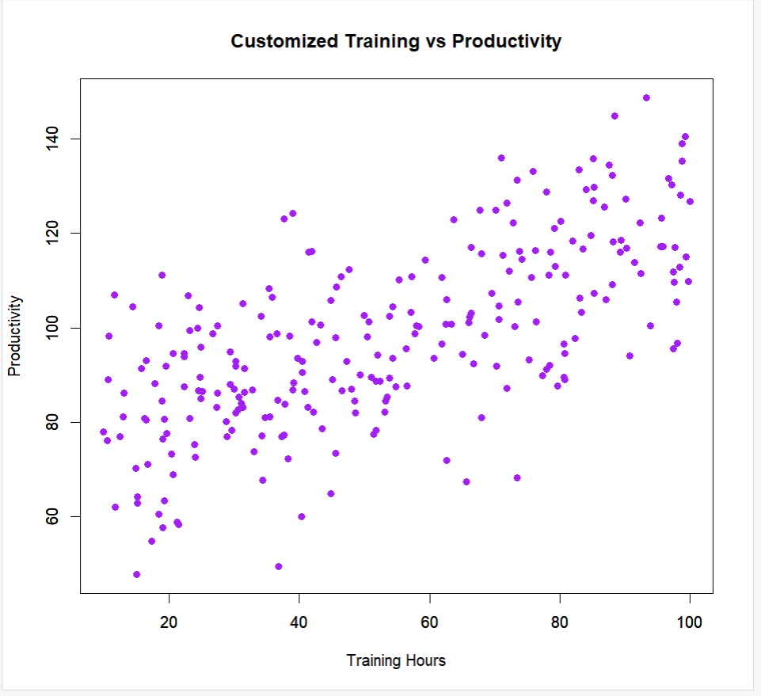
cat("PDF File Saved Successfully!")

4. ROAD ACCIDENT ANALYSIS USING COUNT DATA
# =====================================================
# ROAD ACCIDENT ANALYSIS USING COUNT DATA
# =====================================================

set.seed(123)

# Generate Sample Data (365 Days)
n <- 365

day <- 1:n
traffic_density <- round(runif(n, 50, 200),0)
weather <- sample(c("Sunny","Rainy","Foggy"), n, replace=TRUE)

# Generate Accident Counts using Poisson Distribution
lambda <- exp(-1 + 0.005*traffic_density +
ifelse(weather=="Rainy",0.4,
ifelse(weather=="Foggy",0.6,0)))

accidents <- rpois(n, lambda)

road_data <- data.frame(day, traffic_density,
weather, accidents)

# -----------------------------------------------------
# 1. Bar Plot & Line Chart
# -----------------------------------------------------

# Bar Plot (Total accidents by weather)
weather_total <- tapply(road_data$accidents,
road_data$weather, sum)

barplot(weather_total,
main="Total Accidents by Weather",
col="orange",
ylab="Number of Accidents")

# Line Chart (Daily Trend)
plot(road_data$day, road_data$accidents,
type="l",
main="Daily Accident Trend",
xlab="Day",
ylab="Accident Count",
col="blue")

# -----------------------------------------------------
# 2. Poisson Regression
# -----------------------------------------------------

poisson_model <- glm(accidents ~ traffic_density + weather,
data=road_data,
family=poisson)

summary(poisson_model)

# -----------------------------------------------------
# 3. Interpret Coefficients (Odds Ratio Style)
# -----------------------------------------------------

exp_coef <- exp(coef(poisson_model))
print("Exponentiated Coefficients:")
print(exp_coef)

# -----------------------------------------------------
# 4. Compare with Linear Regression
# -----------------------------------------------------

linear_model <- lm(accidents ~ traffic_density + weather,
data=road_data)

summary(linear_model)

# -----------------------------------------------------
# 5. ggplot2 Visualization
# -----------------------------------------------------

install.packages("ggplot2") # Run once
library(ggplot2)

ggplot(road_data, aes(x=weather, y=accidents,
fill=weather)) +
geom_boxplot() +
labs(title="Accident Frequency by Weather Condition")

# -----------------------------------------------------
# 6. Add Regression Line (Low-Level)
# -----------------------------------------------------

plot(road_data$traffic_density,
road_data$accidents,
main="Traffic Density vs Accidents",
xlab="Traffic Density",
ylab="Accident Count",
pch=19, col="darkgreen")

abline(lm(accidents ~ traffic_density,
data=road_data),
col="red", lwd=2)

# -----------------------------------------------------
# 7. Save Graphs
# -----------------------------------------------------

pdf("Road_Accident_Analysis.pdf")

barplot(weather_total, col="orange",
main="Total Accidents by Weather")

plot(road_data$day, road_data$accidents,
type="l", col="blue",
main="Daily Accident Trend")

plot(road_data$traffic_density,
road_data$accidents,
pch=19, col="darkgreen",
main="Traffic Density vs Accidents")
abline(lm(accidents ~ traffic_density,
data=road_data),
col="red")

dev.off()

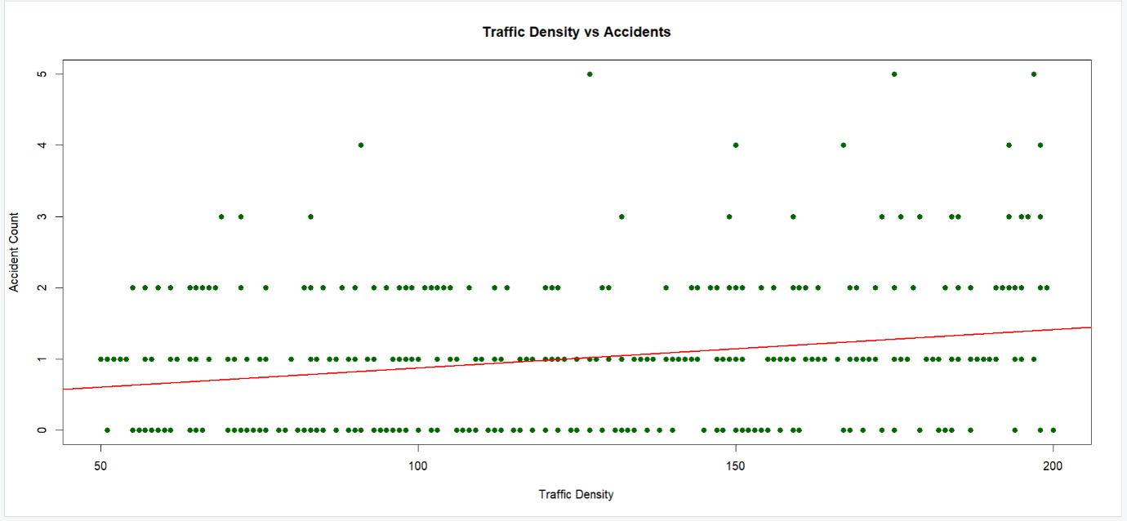
cat("PDF Saved Successfully!")

5. MARKETING CAMPAIGN EFFECTIVENESS
# =====================================================
# MARKETING CAMPAIGN EFFECTIVENESS
# =====================================================

set.seed(123)

# Generate Sample Data (300 Customers)
n <- 300

advertising_cost <- round(runif(n, 1000, 10000),0)

# Customer Reach (continuous outcome)
customer_reach <- round(200 + 0.05*advertising_cost +
rnorm(n,0,50),0)

# Purchase Conversion Probability (Logistic Simulation)
prob_conversion <- 1 / (1 + exp(-(-5 + 0.0004*advertising_cost)))

conversion <- ifelse(runif(n) < prob_conversion,
"Yes","No")

marketing_data <- data.frame(advertising_cost,
customer_reach,
conversion)

# -----------------------------------------------------
# 1. Histogram & Scatter Plot
# -----------------------------------------------------

hist(marketing_data$advertising_cost,
main="Advertising Cost Distribution",
xlab="Advertising Cost",
col="lightblue")

plot(marketing_data$advertising_cost,
marketing_data$customer_reach,
main="Advertising Cost vs Customer Reach",
xlab="Advertising Cost",
ylab="Customer Reach",
col="blue", pch=19)

# -----------------------------------------------------
# 2. Simple Linear Regression
# -----------------------------------------------------

linear_model <- lm(customer_reach ~ advertising_cost,
data=marketing_data)

summary(linear_model)

# Add regression line
abline(linear_model, col="red", lwd=2)

# -----------------------------------------------------
# 3. Logistic Regression
# -----------------------------------------------------

marketing_data$conv_binary <-
ifelse(marketing_data$conversion=="Yes",1,0)

logistic_model <- glm(conv_binary ~ advertising_cost,
data=marketing_data,
family=binomial)

summary(logistic_model)

# -----------------------------------------------------
# 4. Odds Ratio & Probability
# -----------------------------------------------------

exp_coef <- exp(coef(logistic_model))
print("Odds Ratio:")
print(exp_coef)

# Predicted Probability Example
new_data <- data.frame(advertising_cost=5000)
pred_prob <- predict(logistic_model,
new_data,
type="response")

cat("Predicted Conversion Probability at 5000 cost:",
pred_prob, "\n")

# -----------------------------------------------------
# 5. Advanced Visualization using ggplot2
# -----------------------------------------------------

install.packages("ggplot2") # Run once
library(ggplot2)

ggplot(marketing_data,
aes(x=advertising_cost,
y=customer_reach)) +
geom_point(color="blue") +
geom_smooth(method="lm", se=FALSE,
color="red") +
labs(title="Ad Cost vs Customer Reach")

ggplot(marketing_data,
aes(x=advertising_cost,
fill=conversion)) +
geom_histogram(alpha=0.6,
position="identity",
bins=20) +
labs(title="Advertising Cost by Conversion")

# -----------------------------------------------------
# 6. Save Graphs as PNG
# -----------------------------------------------------

png("AdCost_Histogram.png")
hist(marketing_data$advertising_cost,
col="lightblue",
main="Advertising Cost Distribution")
dev.off()

png("AdCost_vs_Reach.png")
plot(marketing_data$advertising_cost,
marketing_data$customer_reach,
col="blue", pch=19)
abline(linear_model, col="red")
dev.off()

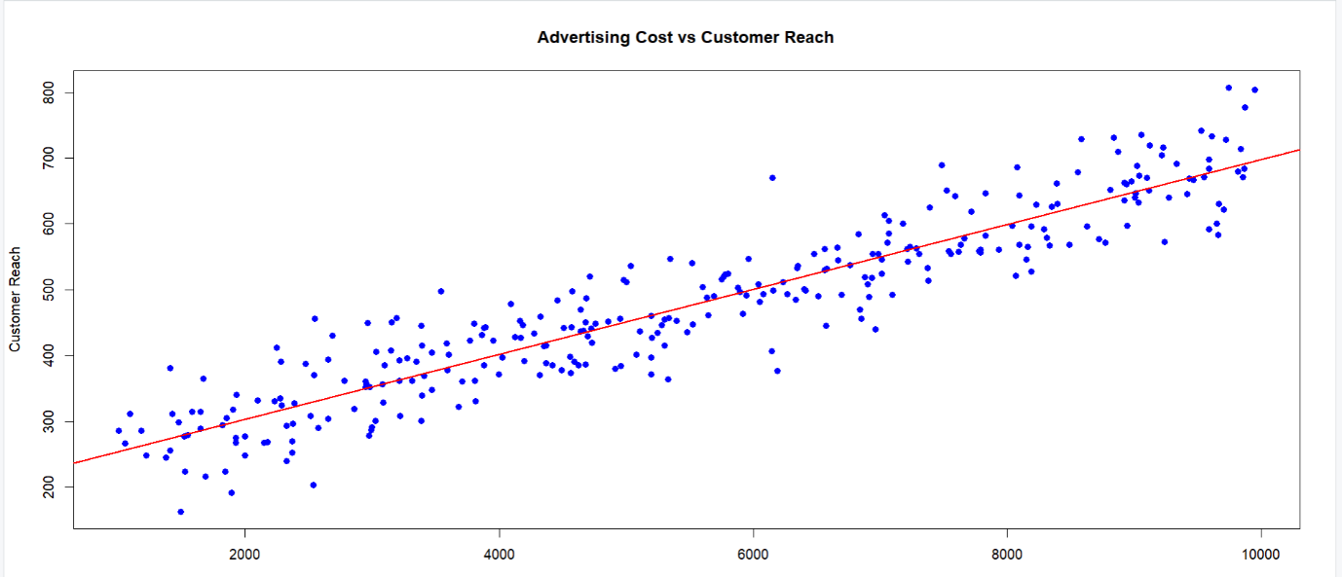
cat("PNG Files Saved Successfully!")

6. ENVIRONMENTAL POLLUTION MONITORING
# =====================================================
# ENVIRONMENTAL POLLUTION MONITORING
# =====================================================

set.seed(123)

# Generate Sample Data (365 Days)
n <- 365

day <- 1:n
PM25 <- round(rnorm(n, 80, 20),1)
temperature <- round(rnorm(n, 30, 5),1)
humidity <- round(runif(n, 40, 90),1)

# Respiratory Cases (Influenced by PM2.5 & Temperature)
resp_cases <- round(10 + 0.2*PM25 + 0.1*temperature +
rnorm(n,0,5))

region <- sample(c("North","South","East","West"),
n, replace=TRUE)

env_data <- data.frame(day, PM25, temperature,
humidity, resp_cases, region)

# -----------------------------------------------------
# 1. Histogram & Density Plot (Pollution)
# -----------------------------------------------------

hist(env_data$PM25,
main="PM2.5 Distribution",
xlab="PM2.5 Level",
col="lightblue",
probability=TRUE)

lines(density(env_data$PM25),
col="red", lwd=2)

# -----------------------------------------------------
# 2. Line Chart (Trend Over Time)
# -----------------------------------------------------

plot(env_data$day, env_data$PM25,
type="l",
main="Daily PM2.5 Trend",
xlab="Day",
ylab="PM2.5 Level",
col="darkgreen")

# -----------------------------------------------------
# 3. Multiple Linear Regression
# Predict Respiratory Cases
# -----------------------------------------------------

model <- lm(resp_cases ~ PM25 + temperature,
data=env_data)

summary_model <- summary(model)
print(summary_model)

# -----------------------------------------------------
# 4. Interpretation Values
# -----------------------------------------------------

cat("\nIntercept:", coef(model)[1])
cat("\nPM2.5 Coefficient:", coef(model)[2])
cat("\nTemperature Coefficient:", coef(model)[3])
cat("\nR-squared:", summary_model$r.squared, "\n")

# -----------------------------------------------------
# 5. Lattice Graph (Region-wise Pollution)
# -----------------------------------------------------

install.packages("lattice") # Run once
library(lattice)

bwplot(PM25 ~ region,
data=env_data,
col="blue",
main="Region-wise PM2.5 Comparison")

# -----------------------------------------------------
# 6. Low-Level Customization Example
# -----------------------------------------------------

plot(env_data$PM25, env_data$resp_cases,
type="n",
main="PM2.5 vs Respiratory Cases",
xlab="PM2.5 Level",
ylab="Respiratory Cases")

points(env_data$PM25, env_data$resp_cases,
col="purple", pch=16)

abline(lm(resp_cases ~ PM25, data=env_data),
col="red", lwd=2)

axis(1)
axis(2)
box()

# -----------------------------------------------------
# 7. Save Visualizations
# -----------------------------------------------------

pdf("Environmental_Pollution_Report.pdf")

hist(env_data$PM25, probability=TRUE,
col="lightblue",
main="PM2.5 Distribution")
lines(density(env_data$PM25), col="red")

plot(env_data$day, env_data$PM25,
type="l", col="darkgreen",
main="PM2.5 Trend")

bwplot(PM25 ~ region, data=env_data)

plot(env_data$PM25, env_data$resp_cases,
pch=16, col="purple",
main="PM2.5 vs Respiratory Cases")
abline(lm(resp_cases ~ PM25, data=env_data),
col="red")

dev.off()

cat("Public Health Report Saved Successfully!")
